Silesian University of Technology

Hierarchical Control Lab-6

Title of the exercise:

“ Optimal control of complex systems ”

Date of the exercise:
20.12.2013

Group Students:
Ismail Kalay
Aiganym Kadrina

Introduction:
In 8 laboratory, students use the sensitivity analysis for gradient estimation of non-linear dynamic systems parameters. As examples of such systems, the Hammerstein and Wiener models are used.
During the eighth laboratory exercise we were supposed to benefit from the model built during the previous laboratory exercise. It was the Hammerstein model with the following transfer function:
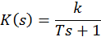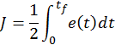
e – error
t_{f} – final time (10 seconds)

Constants for section 5: a=2, b=3, k=1, T=2

Main task of this laboratory was to minimize performance index what is equal with minimize error using adjoint model of given system. We used gradient method. We have given reference trajectory given by tutor. We created model in Simulink of system and tried to tune system in such a way to make the output of the system most similar to the reference trajectory.

Task 1: First we modified Hammerstein-Wiener model from 7th exercise. Main problem was to add module, which will take input signal from Matlab script and export given error of the system to the workspace. This error was used in the further part of calculations.
In the following figure model is presented:

clc;clear;
%constants
tfinal = 10;
tstep = 0.1;
d = zeros(1, 101);
u = zeros(size(d));
e_1 = zeros(size(d));
t = (0:tstep:tfinal);
c = 0.07;
error = 0;
stop_criter = 3;
max_iter = 500;
counter = 0;

% Obtain trajectory
for i=1:1:round(0.3*length(d))
d(i) = 0;
end
for i=round(0.3*length(d) + 1):1:round(0.7*length(d))
d(i) = -3.0;
end
for i=round(0.7*length(d) + 1):1:length(d)
d(i) = 0;
end

% Plot trajectory
plot(t,d);
xlabel('Time [s]');
ylabel('d(t)');
axis([0 10 -4 1]);

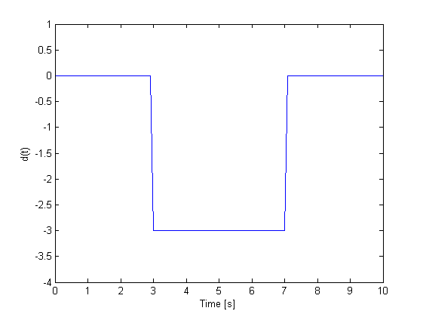

The Simulink model is shown:
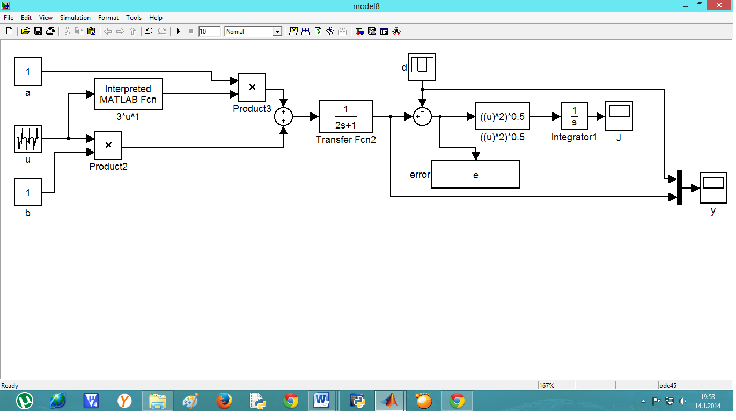

Adjoint Model:

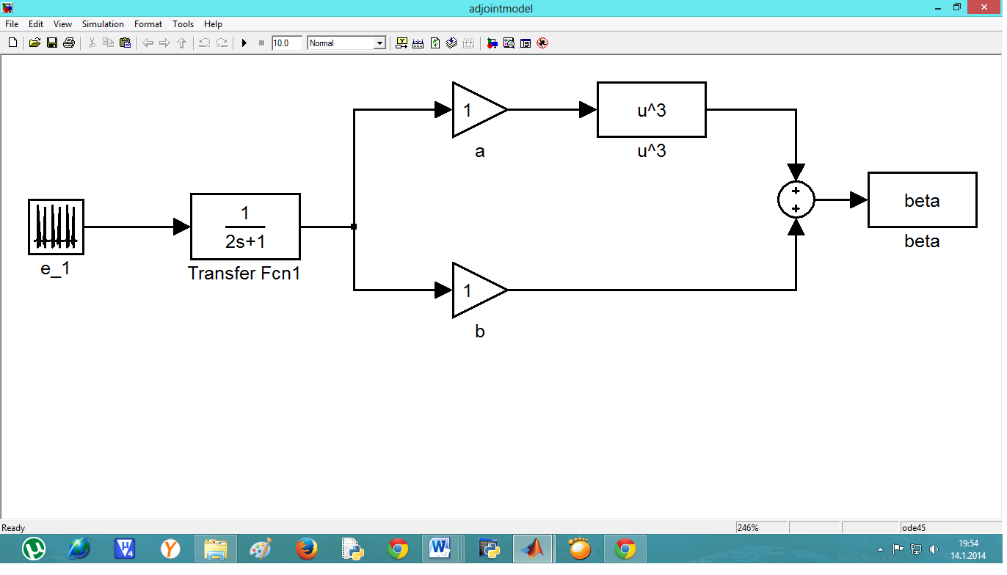

flipud(A) means:
If A is a column vector, then flipud(A) returns a vector of the same length with the order of its elements reversed.

% loop part for calculating
for index=1:1:max_iter
counter = index;
sim('model8',[0 tfinal]);
e_1 = flipud(e);
sim('adjoint',[0 tfinal]);
beta_1 = flipud(beta);
for i=1:1:length(u)
u(i) = u(i) - c*beta_1(i);
end
error = sum(abs(e));
if (error < stop_criter)
break;
end
end
counter
error

Trial 1:

c = 0.07;
error = 0;
stop_criter = 15;
max_iter = 500;

Result 1:
counter =
113
error =
1.4987e+001

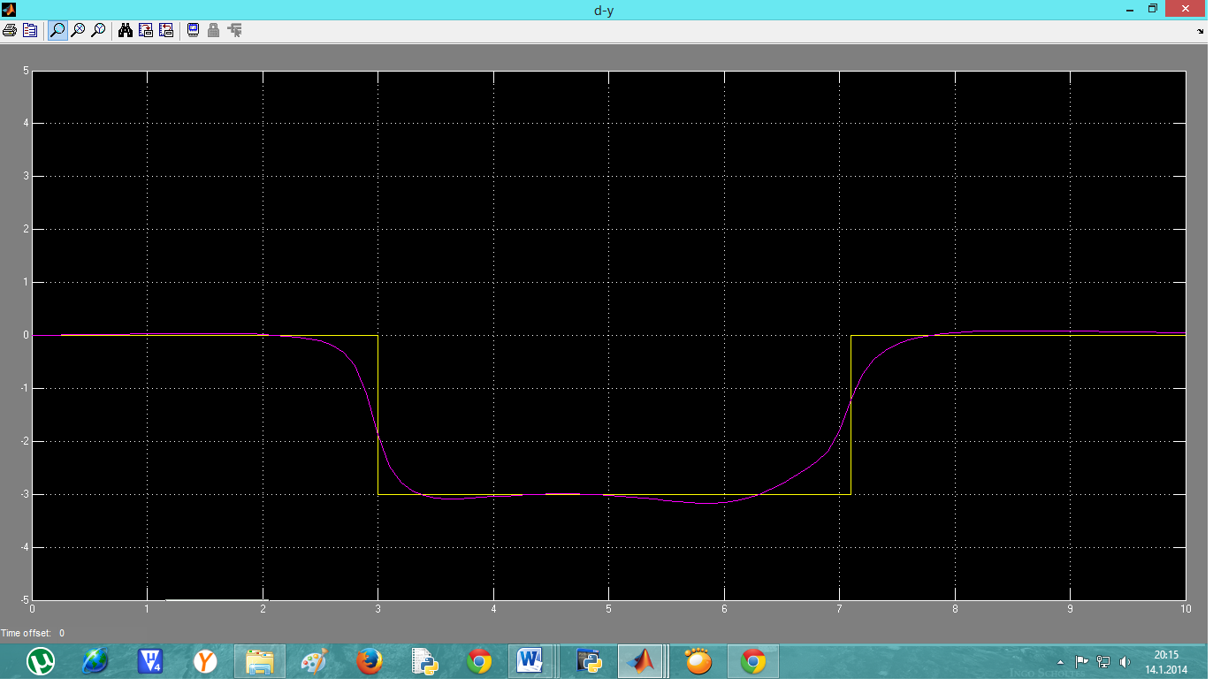

Trial 2:
c = 0.07;
error = 0;
stop_criter = 8;
max_iter = 500;

Result 2:

counter =
316
error =
7.9888e+000

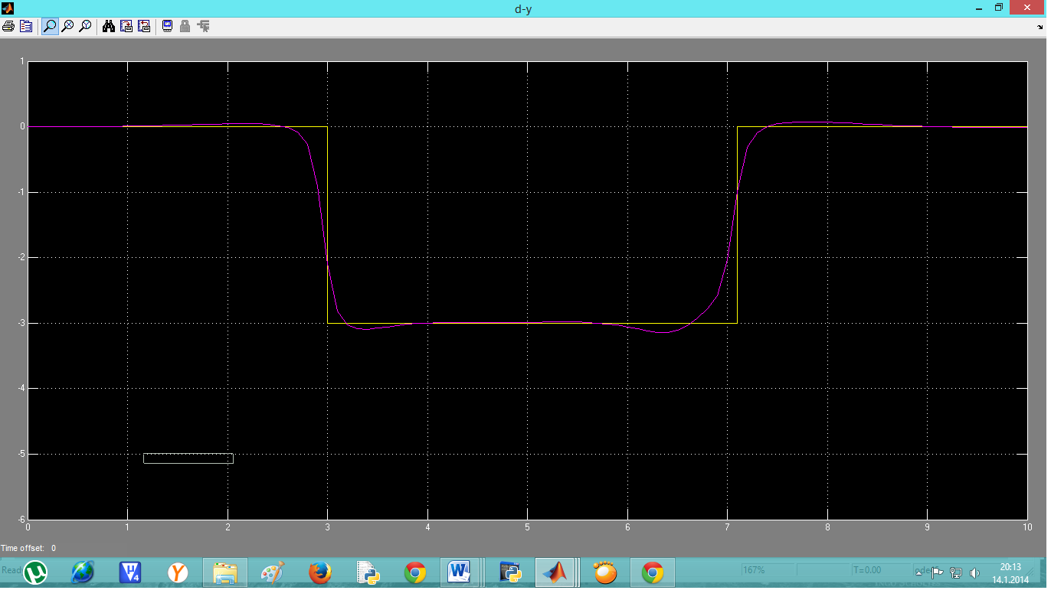

Trial 3:
c = 0.07;
error = 0;
stop_criter = 3;
max_iter = 500;

Result 3:

counter =
500
error =
6.0662e+000

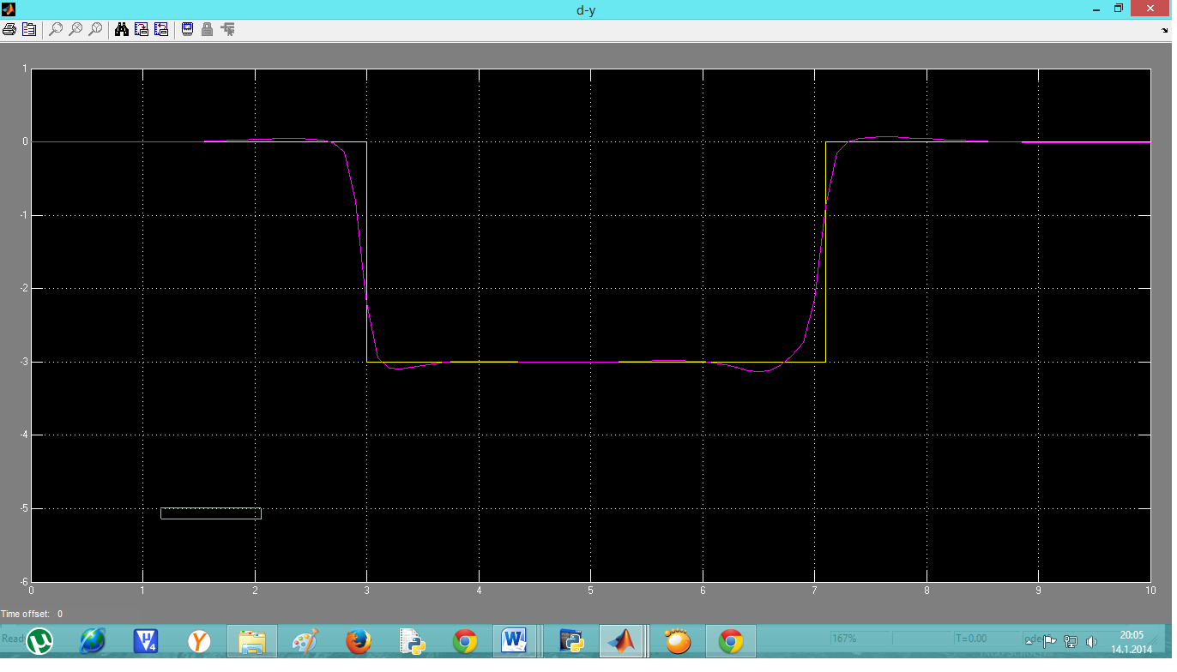

Conclusion:

We can see easily that with decreasing stop criterion number of iteration is rising.
Also we observed that:

- The greater small positive constant value, the faster the algorithm.
- Decreasing stop criterion number of iteration is rising.
- When stop criterion equal to 3, number of iteration was filled (no of 500 iteration) .In this case error is greater then stop criterion, because number of iteration was not enough large.

